23AI2003 –Artificial Intelligence for Web Development Lab
URK23CS5003

Ex. No: 07 | Node.js Web Server for Displaying Greeting Message and Current Date & Time

Aim

To develop a simple web server using Node.js that displays a greeting message along with the current date and time in a web browser.

Description

The application allows users to access a simple web server created using Node.js, where a greeting message along with the current system date and time is displayed in the browser. When the user enters the URL in the browser, the server processes the request and dynamically generates the response using the built-in HTTP module. The date and time are retrieved from the system and updated each time the page is refreshed. This experiment demonstrates the basic working of a Node.js server, handling HTTP requests and responses, and generating dynamic content.

Code
const http = require("http");

const server = http.createServer((req, res) => {
const name = "Evangeline"; // put your name
const currentTime = new Date();

res.writeHead(200, { "Content-Type": "text/html" });

res.write(`<h2>Hello from ${name}'s Node.js Server</h2>`);
res.write(`<p>Current Date and Time: ${currentTime}</p>`);

res.end();
});

server.listen(3000, "0.0.0.0", () => {
console.log("Server running at http://localhost:3000");
});

Input & Output
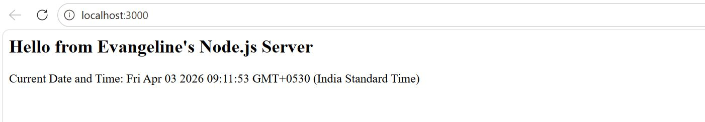

Result
The experiment was successfully completed.

